BEEKMAN & QUEEN CITY AVENUE STRATEGIC DEVELOPMENT GUIDEBOOK

Recommendations Feedback

- What are your thoughts on the “Change the Rules” recommendations?
Zoning Reform, Encourage Historic Preservation in Key Areas, Utilize Neighborhood Enhancement Program

________________________________________________________________________
________________________________________________________________________
________________________________________________________________________

- What are your thoughts on the “Re-Activate Real Estate” recommendations?
Reposition Historic Buildings for the Future, Develop and Maintain a Community Led Inventory of Vacant Buildings, 21st Century Industry

________________________________________________________________________
________________________________________________________________________
________________________________________________________________________

- What are your thoughts on the “Build a Brand” recommendations?
Promote Every Thing Every Place, Utilize Equitable Development Rubric, Economic Opportunity for Existing Residents

________________________________________________________________________
________________________________________________________________________
________________________________________________________________________

- What are your thoughts on the “Change the Rules” recommendations?
Build Streets for People, Expand Bike Infrastructure, Promote Pedestrian Connections, Leverage Reinventing Metro

________________________________________________________________________
________________________________________________________________________
________________________________________________________________________

- What are your thoughts on the identified nodes and gateways?
Northern Gateway, Center of the Fairmounts, South Gateway, Queen City Ave Between Rankin & Merton, Beekman Opposite Neyer

________________________________________________________________________
________________________________________________________________________
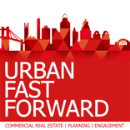
________________________________________________________________________
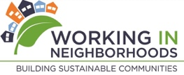

Place a dot on the map where you think each activation strategy would best work.

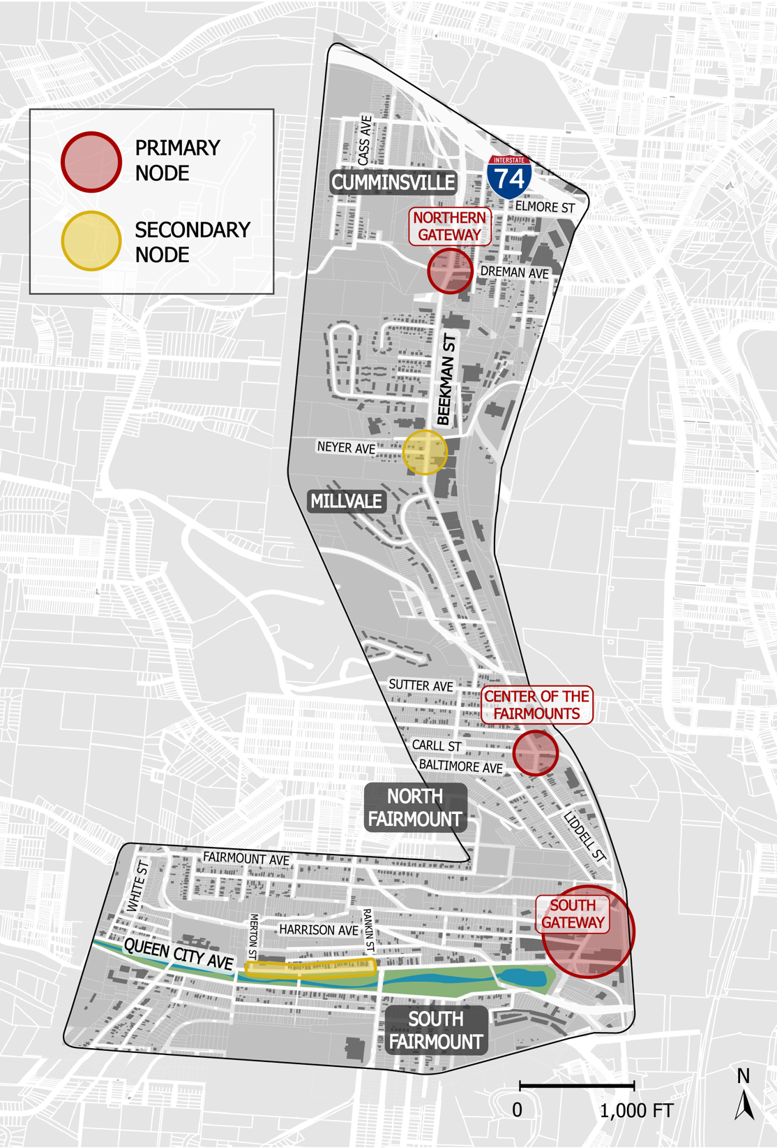
Community Garden
Green
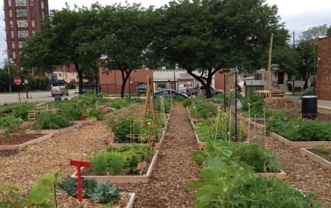

Mobile Food Fest
Pink
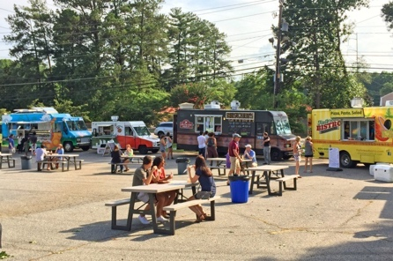

Street Painting
Orange
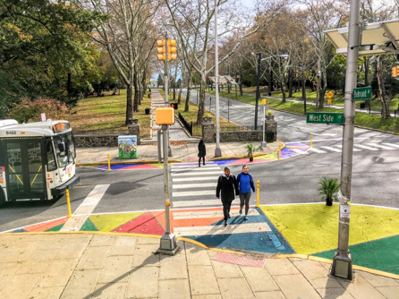

Pocket Park
Yellow
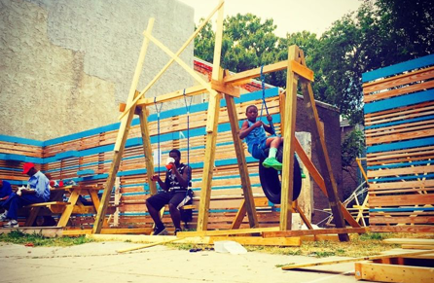

Do you have other ideas for activation in these areas?

________________________________________________________________________
________________________________________________________________________

